Exercise Section II
(AC circuits analysis)
=============================================================

1. Find the current in an inductance of 5.0 mH, given the voltage across the element,

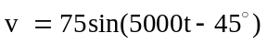 V
Ans. 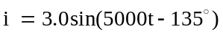 A

2. In Fig.1, 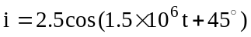 A. Obtain the voltage v.
Ans. 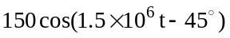 V

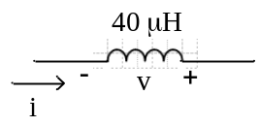
Fig.1

3. The circuit element in Fig.2 has a current 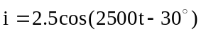 A and a voltage
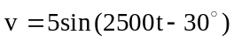 V. What is the element ?
Ans. 200 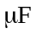 capacitor

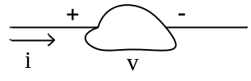

Fig.2

4. The voltage and current sine waves in Fig.3 both pass through zero every 1.26 ms, and the
maximum values are 120 V and 0.40 A. What single circuit element does this indicate ?
Ans. a 120 mH inductor

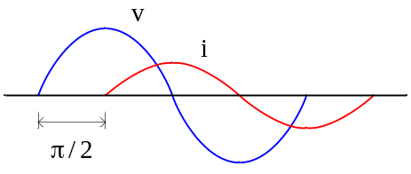

Fig.3

5. Two circuit elements in a series connection have current and total voltage

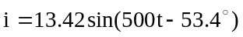 A 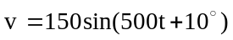 V

Identify the two elements. Ans. R = 5 Ω, L = 20 mH

6. Two circuit elements in a series connection have current and total voltage

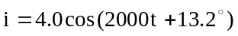 A 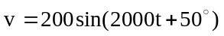 V

Identify the two elements. Ans. R = 30 Ω, C = 12.5 µF

7. The circuit shown in Fig.4 has a current 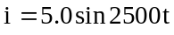 mA. Find the maximum values
of
(a) 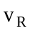
(b) 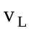
(c) 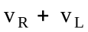
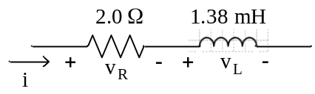
Fig.4

Ans. (a) 10 mV; (b) 17.3 mV; (c) 20 mV

8. A series RC circuit, with R = 27.5 Ω and C = 66.7 µF, has sinusoidal voltage and current,
with angular frequency 1500 rad/s. Find the phase angle by which the current leads the
voltage.
Ans. 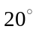

9. A series RLC circuit, with R = 15 Ω, L = 80 mH, C = 30 µF, has a sinusoidal current at
angular frequency 500 rad/s. determine the phase angle and whether the current leads or
lags the total voltage.
Ans. 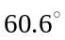, leads

10. In Fig.5, 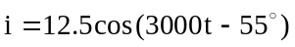 A and 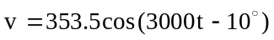 V. Find R and C
Ans. 20 Ω, 33.3 µF

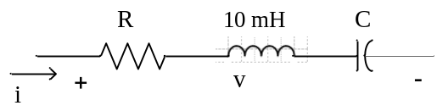
Fig.5

11. A resistance R = 10 Ω and an inductance L = 5.0 mH are in parallel . The inductive –
branch current is
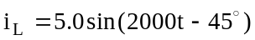 A
Obtain the total current, 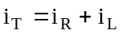, and the angle by with i_{T} lag the voltage v.
Ans. 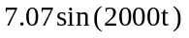 A, 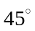

12. A two – branch parallel circuit, with R = 10 Ω in one branch and C = 100 µF in the other,
has a voltage
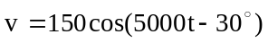 V
Find the total current, 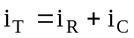
Ans. 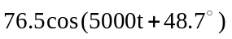 A

13. A capacitor C = 35 µF is in parallel with a certain element. Identify the element, given
that the voltage and total current are
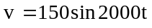 V 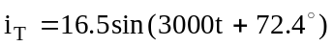 A
Ans. R = 30.1 Ω

14. three parallel branches respectively contain R = 300 Ω, L = 0.50 H, C = 10 µF. Given
the voltage 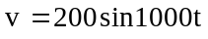 V, determine if the total current leads or lags the voltage,
and by how much.
Ans. Leads by 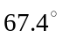

15. Use phasor methods to obtain the current i in Fig.6 , given

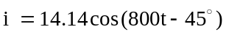 A
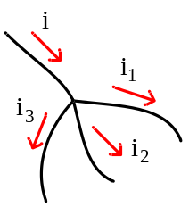

Fig.6
Ans. 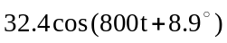 A

16. Use phasor methods to obtain the current v₁ in Fig.7 , given

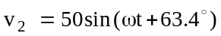 V 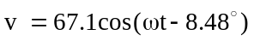 V

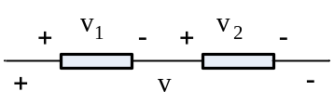

Fig.7

Ans. 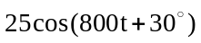 V

17. For the circuit shown in Fig.8 , obtain 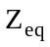 and compute I

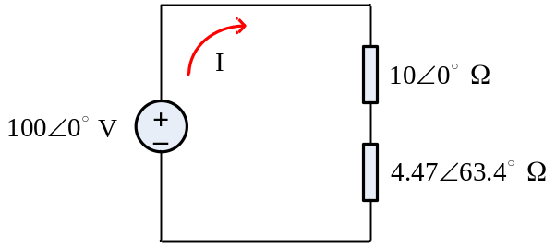

Fig.8
Ans. 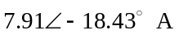

18. Evaluate the impedance 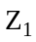 in the circuit of Fig.9

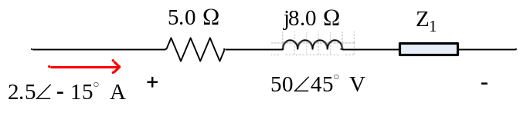
Fig.9
Ans. 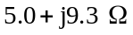
19. Compute the equivalent impedance Z_{eq} and admittance Y_{eq} for the four-branch circuit of
Fig.10
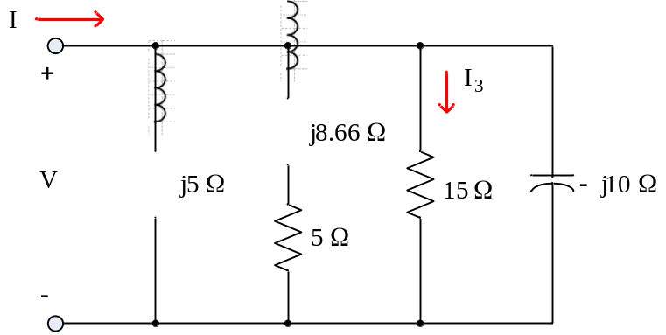

Fig.10

Ans. 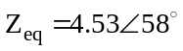Ω, 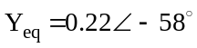 S

20. The total current I entering the circuit shown in Fig.10 is 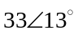 A. Obtain the branch
current I₃ and the voltage V.
ans. 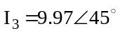 A, 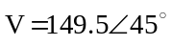 V

21. Find I₁ and I₂ in the parallel circuit of Fig.11

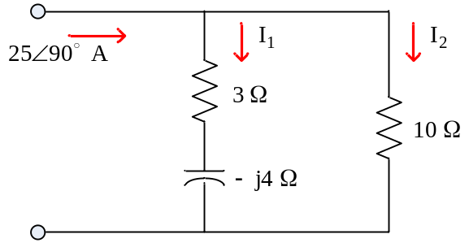

Fig.11
Ans. 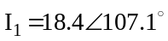 A, 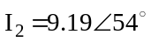 A,

22. For the network of Fig.12 . Obtain 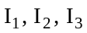

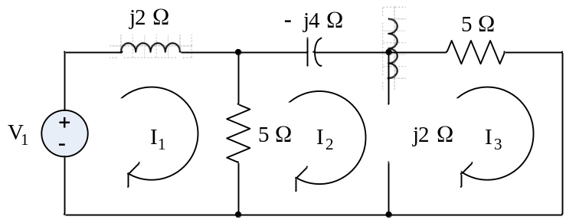

Fig.12

23. Using the node voltage method, find the voltage of node 1 in Fig.13 with respect to the
reference.

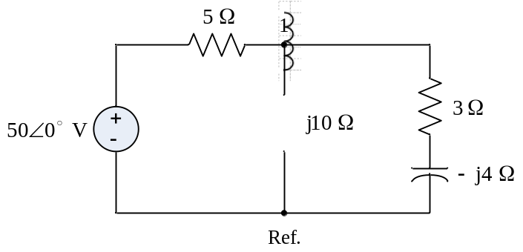

Fig.13

Ans. 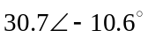 V

